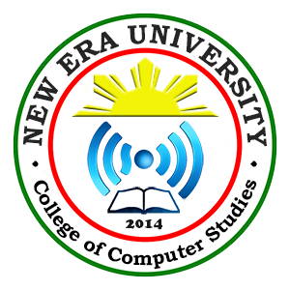

New Era University

College of Computer Studies

Department of Information Technology

FUNERAL MANAGEMENT SYSTEM

San Juan, Jamina Carla M.

Decena, Louie Jhay M.

Garcia, Judy Anne Q.

Juan, Erwin Roy F.

Calimlim, Daryl Sheen

IT313L – FRIDAY – 10:00 AM TO 1:00 PM

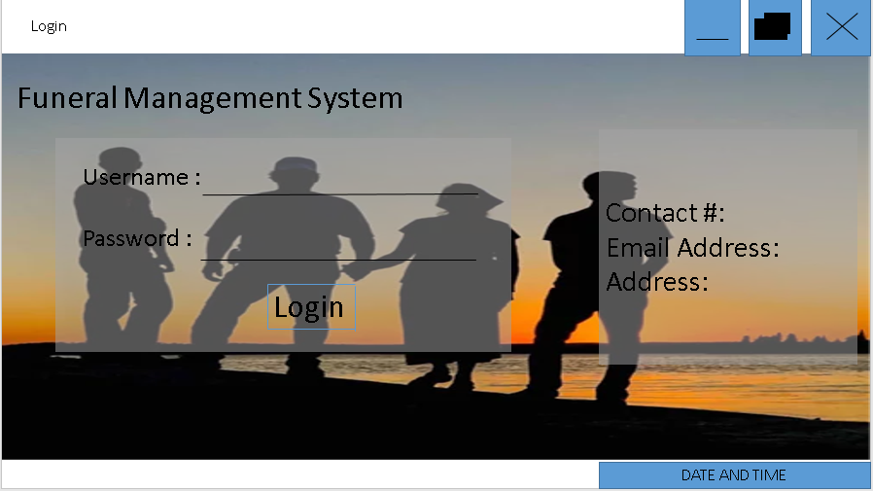

The Administrator and the Family member will login to see the home page of the website and you can view the Contact #, Email Address and the Address.

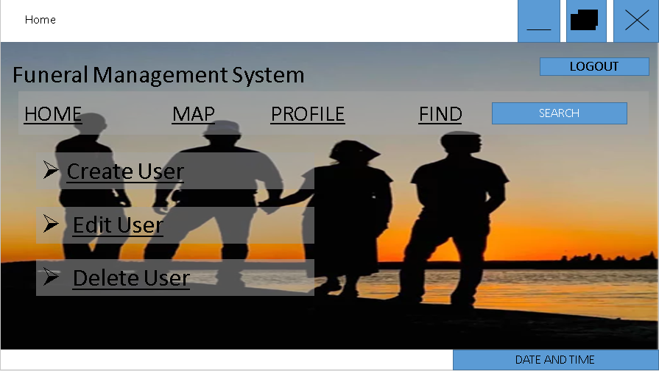

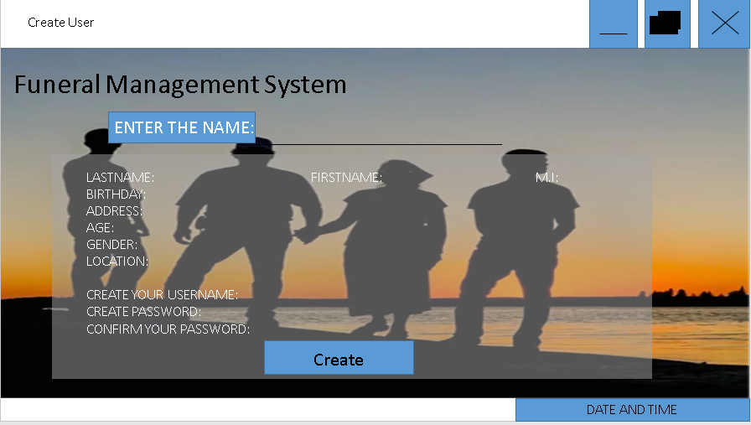

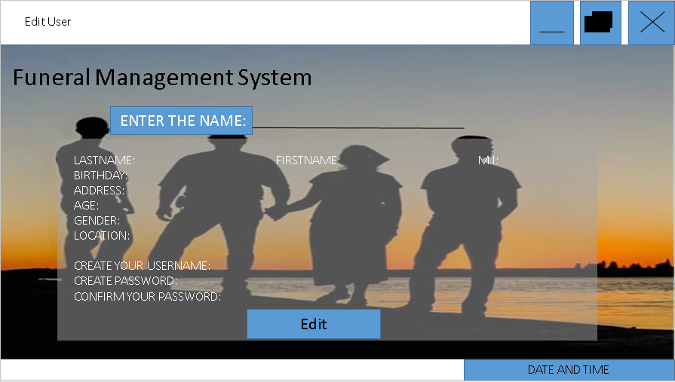

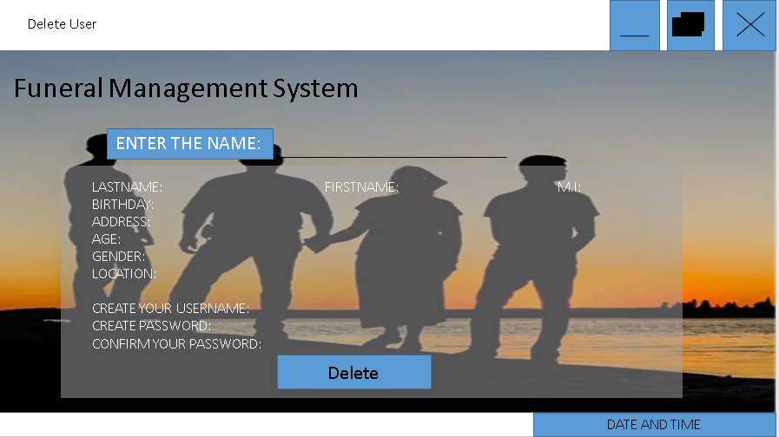

The Administrator is the only one who create, edit or delete the User account.

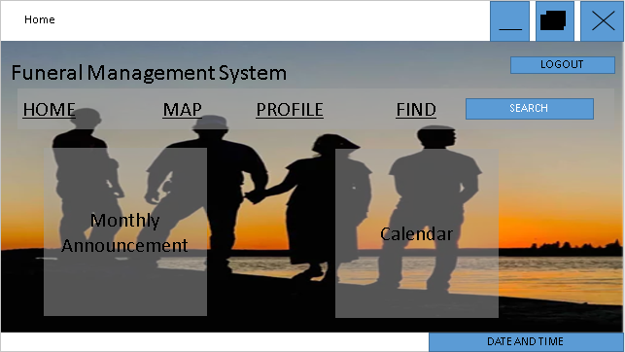

You can view the Announcement and the Calendar. Also in this page you can look into the map where your Family member or your friend located. It also provides the information about the dead person.

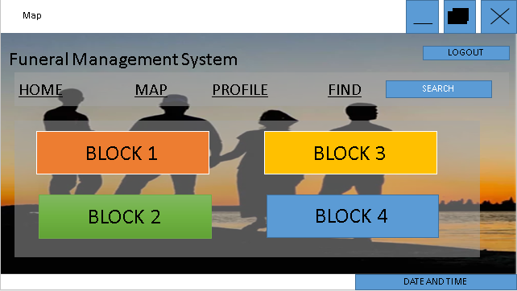

You can look into the map where your family member or your friend located.

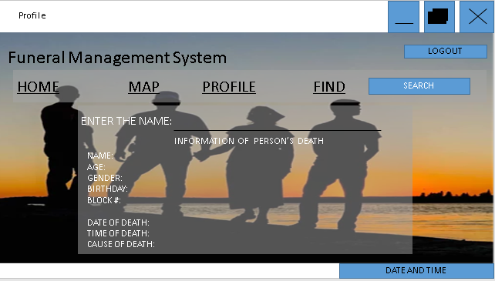

This is where you can find the Information of your Loved ones.